- The strength of the UK jobs market has helped to mitigate the impact of high inflation on households and been a primary factor motivating restrictive monetary policy. But evidence that labour market conditions are softening points to major challenges on the horizon in 2025, including the following three key issues.
- Serious data problems leave major blind spots. The UK's main source of labour market data, the Labour Force Survey, is unusable due to low response rates. It will take another two years to fully resolve the problems. The relative strength of other employment series raises question marks over whether a feature of recent years – the UK's inactivity problem, unique among major economies – exists or whether it's a statistical mirage.
- Jobs strength has relied heavily on the public sector. The bulk of net job creation since 2019 has been in the public sector. Higher public spending should sustain the momentum in the near-term, but spending plans are much tighter thereafter. Several sectors employing the most people have struggled since the pandemic and it's far from certain they could pick up the slack.
- NICs and national living wage increases pose major challenges for firms. Though wage growth has softened, firms face sharply rising labour costs from increases in employers' national insurance contributions and the national living wage. Firms employing large numbers of lower paid workers will face a particularly large jump in their cost base.
The labour market has been a source of strength for the UK economy in recent years. A combination of strong job creation and robust wage growth has provided solid support to household incomes, mitigating the impact of high inflation. The jobs market has also been an important influence on monetary policy, with fears about the tightness of the labour market and the strength of pay growth encouraging the Bank of England to raise its policy rate to a higher level than other major central banks, and then to adopt a relatively cautious approach to subsequent rate cuts.
Chart 1: Most labour market indicators have softened but remain stronger than historical norms
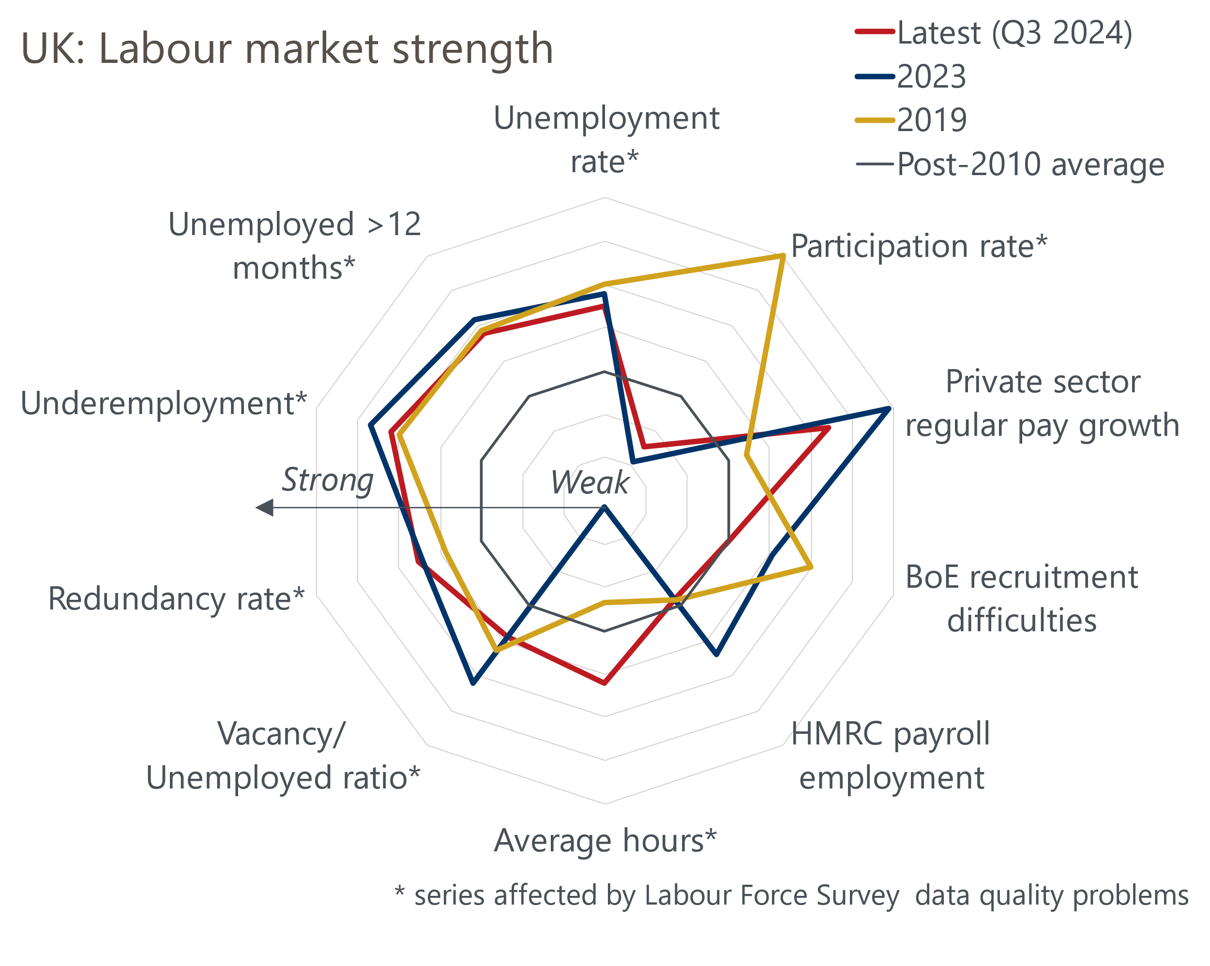
Sources: Oxford Economics, Haver Analytics

If anything, the role of the labour market will be even more crucial in 2025. On the activity front, our growth forecast relies on a stronger contribution from consumers which, in turn, assumes that continued solid growth in income from wages and salaries will mitigate the impact of higher inflation. The evolution of pay growth will be a key influence on the Monetary Policy Committee's verdict on which of its three inflation scenarios is playing out and, therefore, how quickly policy should be loosened.
Most indicators suggest labour market conditions are weaker than they were last year, but stronger than the average since the global financial crisis (Chart 1). But business surveys suggest April's increases in national insurance contributions and the national living wage pose major threats to this resilience.
Given the importance of the labour market to the 2025 outlook, we plan to publish a series of notes looking at the key issues. Here, we identity the main sources of uncertainty.

Serious data problems leave major blind spots
The long-running problems with UK labour market data are serious and unlikely to be resolved for some time. The Office for National Statistics originally suspended publication of data from its flagship Labour Force Survey in October 2023 due to concerns that low response rates meant the data was no longer reliable. Though publication of LFS data subsequently resumed, the most serious problems remain unresolved and the ONS has recently advised that the transition to its permanent solution – the Transformed LFS – will not be complete until 2027.
Small samples have increased volatility. The ONS uses the three-month average of monthly observations as its headline series for the unemployment rate. Recently the range of monthly estimates used to calculate the three-month average has been much wider than before the pandemic – on one occasion in 2023, the difference between the highest and lowest estimates was 1ppt for a three-month average of 4.2% (Chart 2). Furthermore, the fall in sample sizes has not been uniform across age cohorts and other characteristics, exacerbating concerns about how representative the data is.
Chart 2: Unemployment estimates have become very noisy since the pandemic
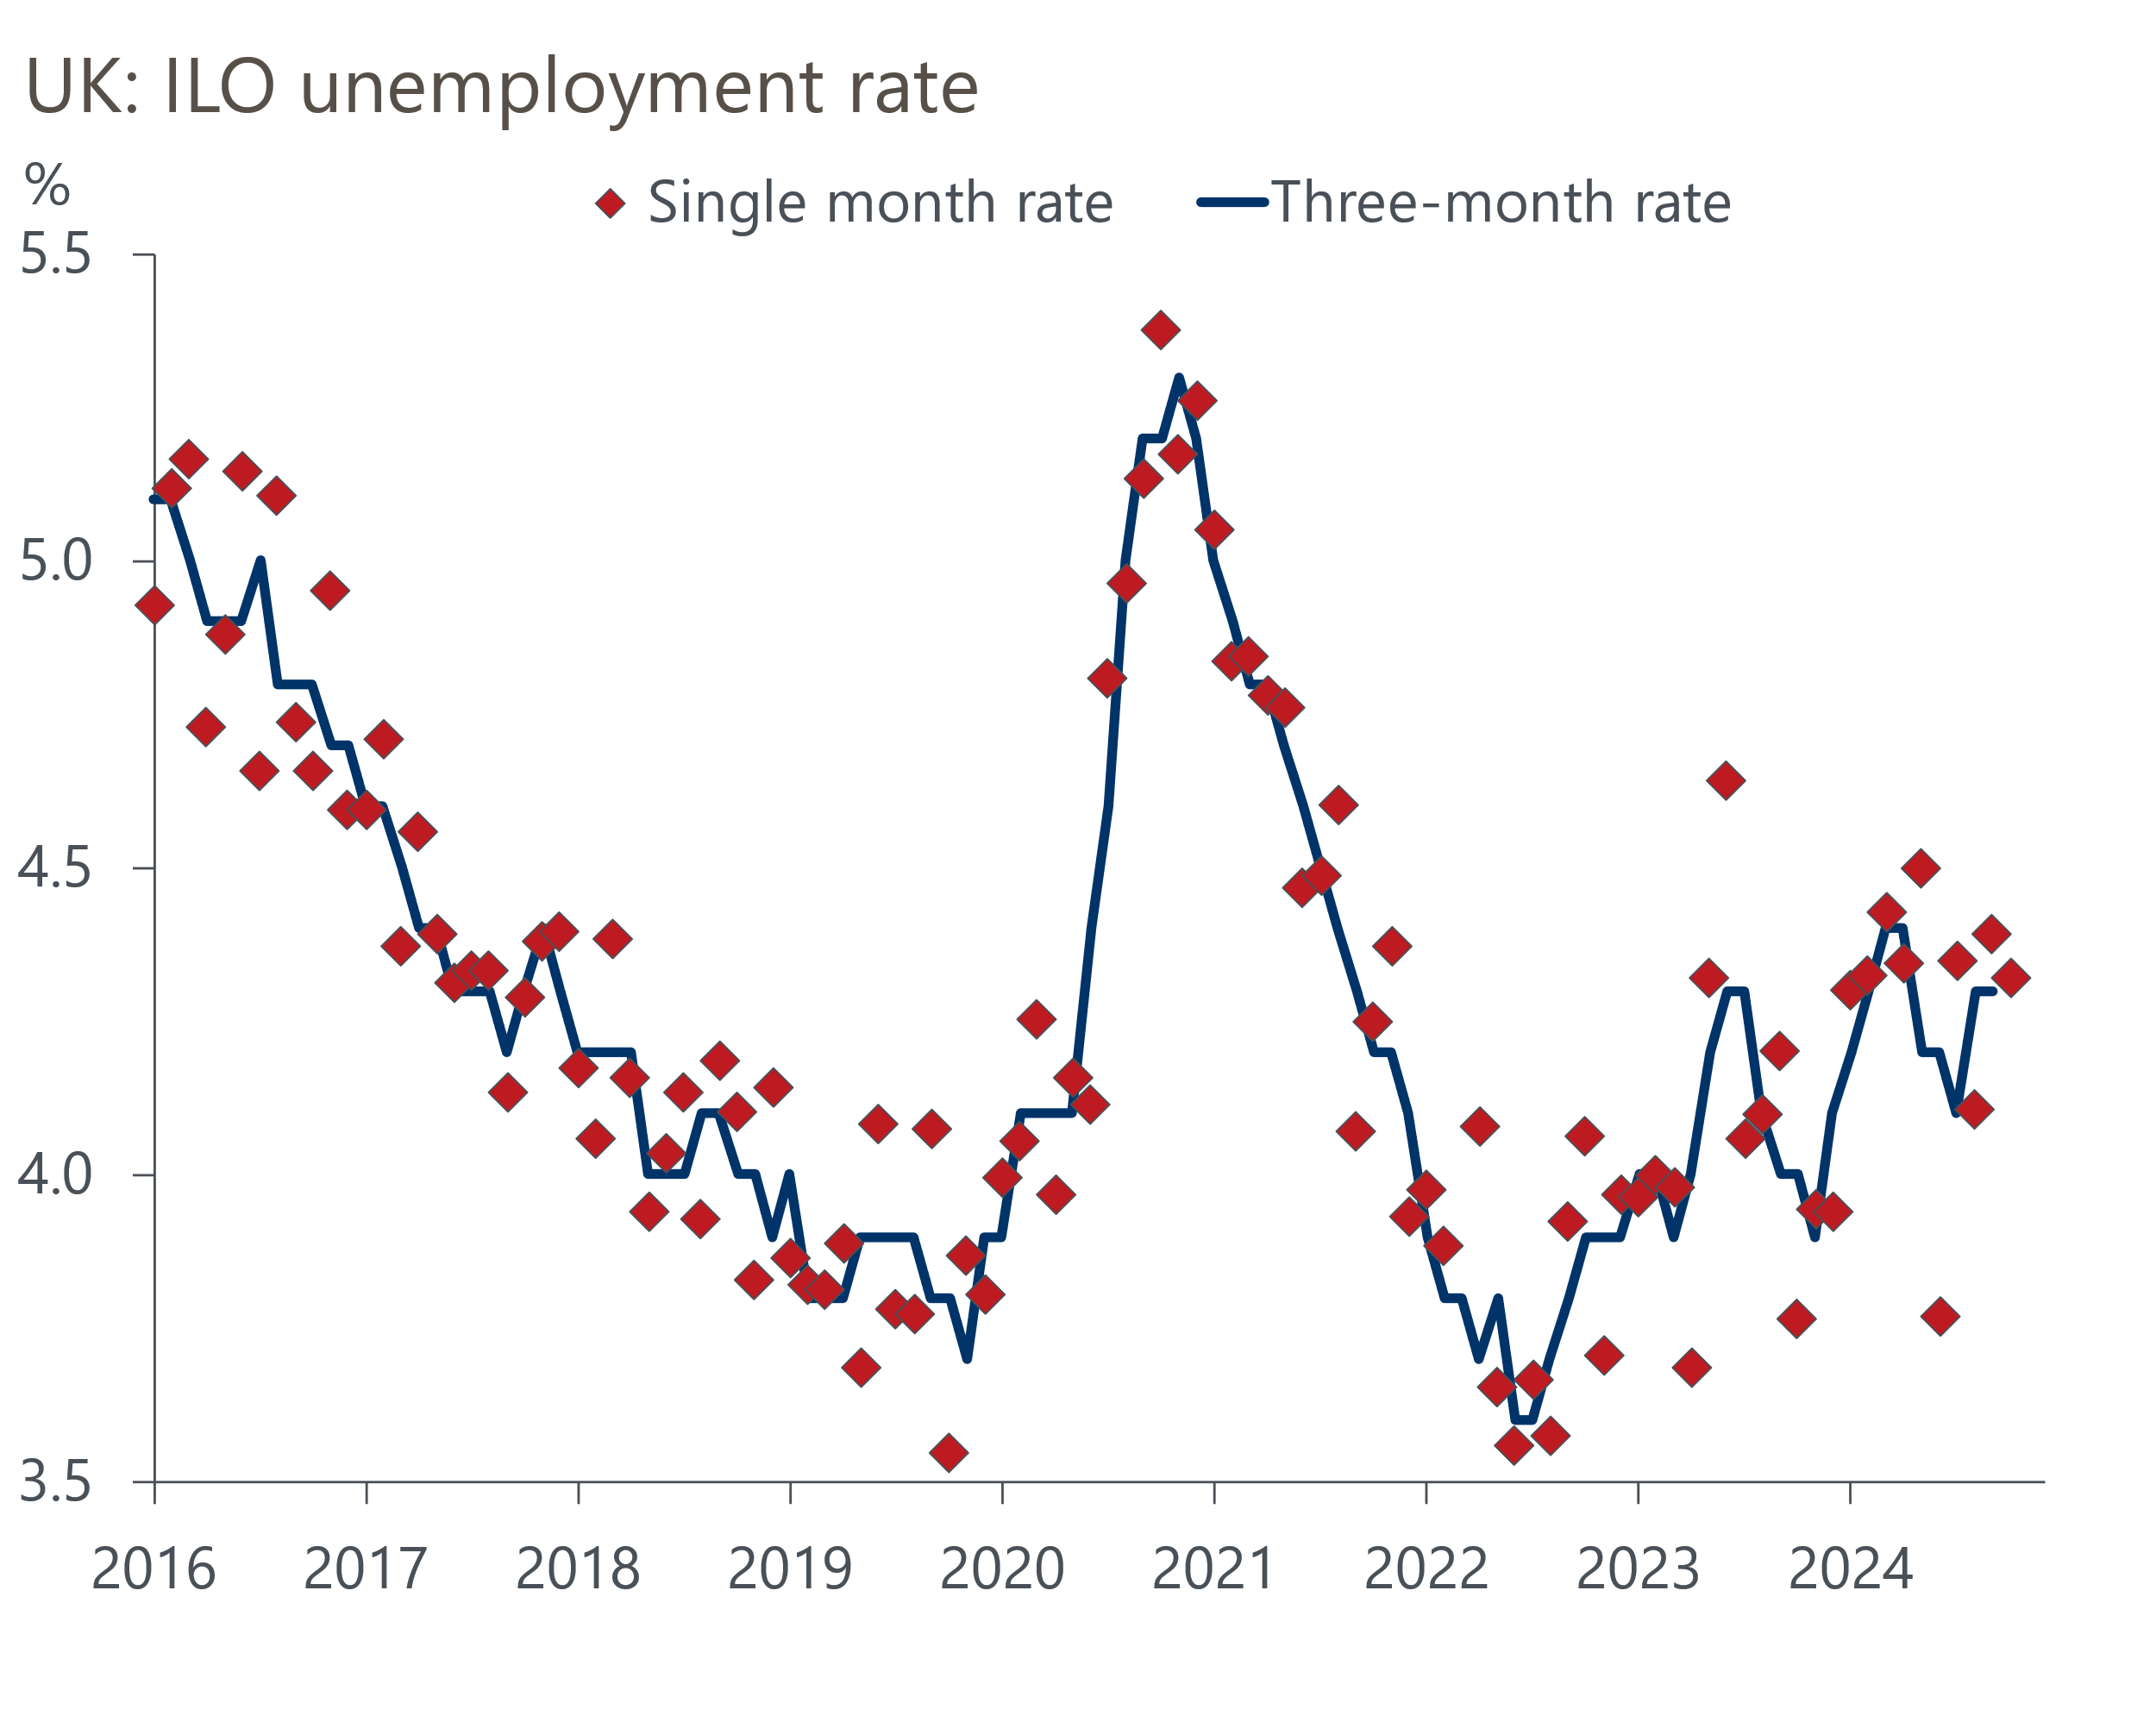
Source: Haver Analytics
In recent years, estimates of employment levels from the LFS have tended to be much lower than other sources, such as the ONS' workforce jobs series and HMRC's count of employees on payrolls. In part, this likely reflects the fact that the ONS is also experiencing major challenges with accurately measuring the UK population. In November, the ONS made large upgrades to its estimates of net inward migration, with net inflows from mid-2021 to mid-2024 now reported to have been 435,000 higher than was assumed in the most recent population projections. The ONS is yet to integrate the new figures into its population estimates or its LFS series.
Data challenges create multiple problems – noisy data makes it harder to identify trends and turning points. Meanwhile doubts over the levels and representativeness of survey data raise questions about key narratives. For example, recent research from Resolution Foundation argued that the LFS problems mean that the inactivity rate has been "materially overestimated". If this analysis is correct, the claim that the UK is alone among the major economies in having developed a major inactivity problem since the pandemic might not be true. This also has implications for the MPC's judgement about the tightness of the labour market and its implications for pay growth and inflation.
To fill the information void, we have published our proprietary high-frequency sentiment dataset, developed in collaboration with Penta. The dataset consists of daily sentiment data constructed using natural language processing from 400,000 sources. We've then used the labour market topics to build nowcasts for UK employment and earnings growth. These indicators are far timelier than official sources and can also act as a check on ONS series at a time when the reliability problems undermine confidence in official data.

Jobs strength has been heavily reliant on the public sector
The relative strength of job creation since 2019 looks less impressive when looked at on a sectoral basis. The ONS' split of private and public sector employment is based on LFS data, so comes with a loud health warning. But it shows that two-thirds of the net job creation since 2019 has been in the public sector.
Though the workforce jobs dataset also uses the LFS as an input, it's based on a broader range of sources and is considered more reliable. The sectoral breakdown also shows a strong reliance on the public sector. The health sector has been responsible for just over half of net job creation since 2019. When public administration and education are added, industries that are dominated by the public sector account for 77% of the net job creation since the pandemic started (Chart 3).
Chart 3: The public sector has accounted for most of the net job creation since 2019
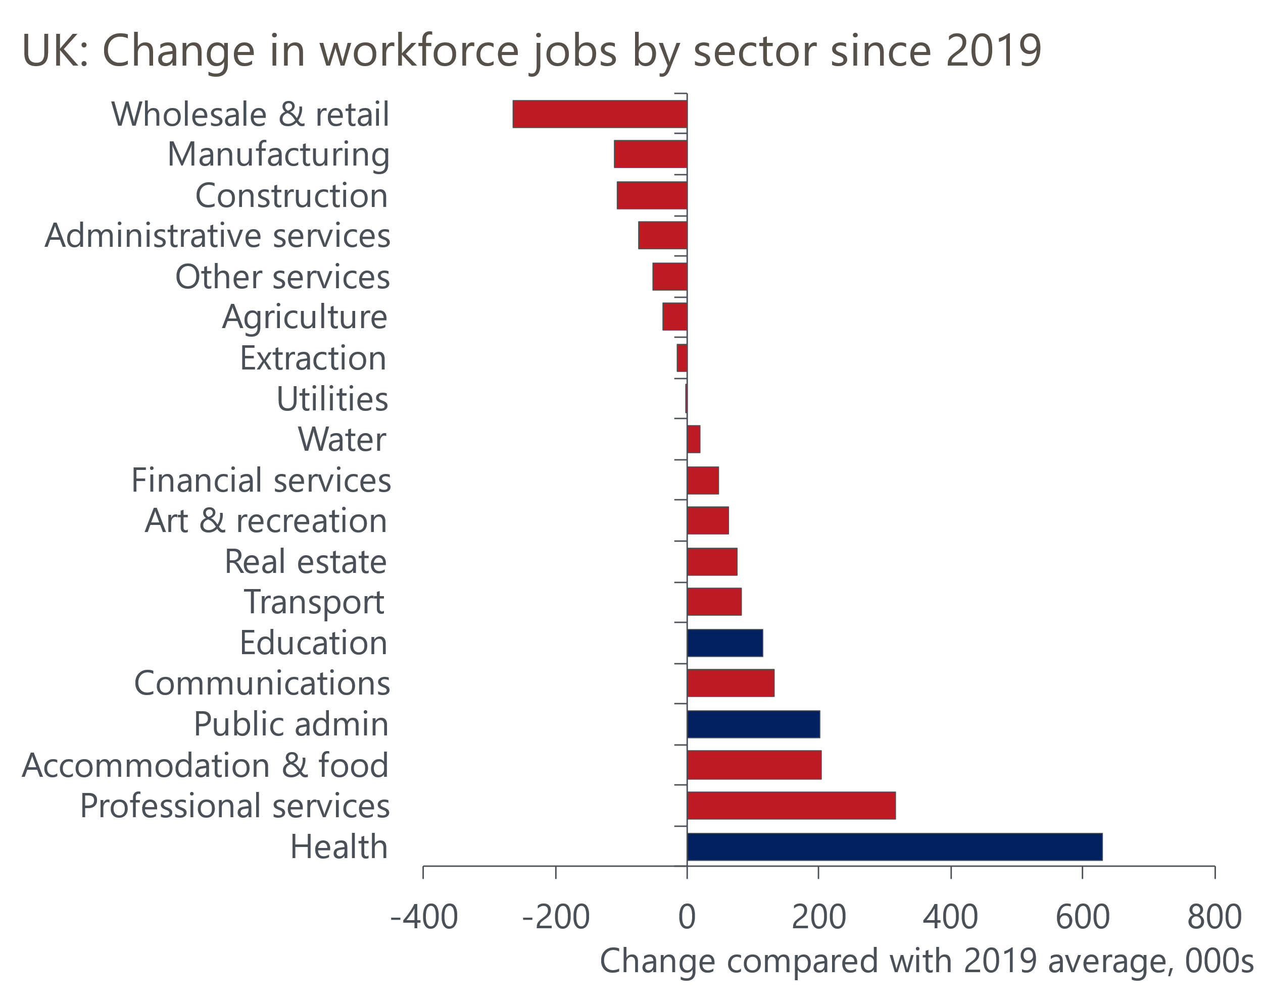
Source: Haver Analytics
By contrast, large parts of the private sector continue to struggle. Around a third of sectors have lower employment now than in 2019, including wholesale and retail, manufacturing, construction, and administrative services – these are all large sectors that collectively account for just over a third of UK jobs.
The extra current government spending announced in the October 2024 Budget should drive further job creation in the public sector this year. But spending plans are much tighter thereafter, putting a much greater onus on the private sector to drive jobs growth moving forwards.

NICs and national living wage increases pose major challenges for firms
As well as a stuttering economy, the outlook for private sector job creation will be complicated by two key policy changes from April – the increase in employers' national insurance contributions and the 6.7% increase in the national living wage.
In their Decision Maker Panel surveys for November and December, the BoE asked firms how they planned to react to the NICs increase. More than half of firms expect to lower margins, raise prices, and reduce headcount. The proportion expecting to offer smaller pay rises was lower, but at just under 40% was still fairly high (Chart 4).
Chart 4: Most firms expect to lower headcount and pay growth because of the NICs rise
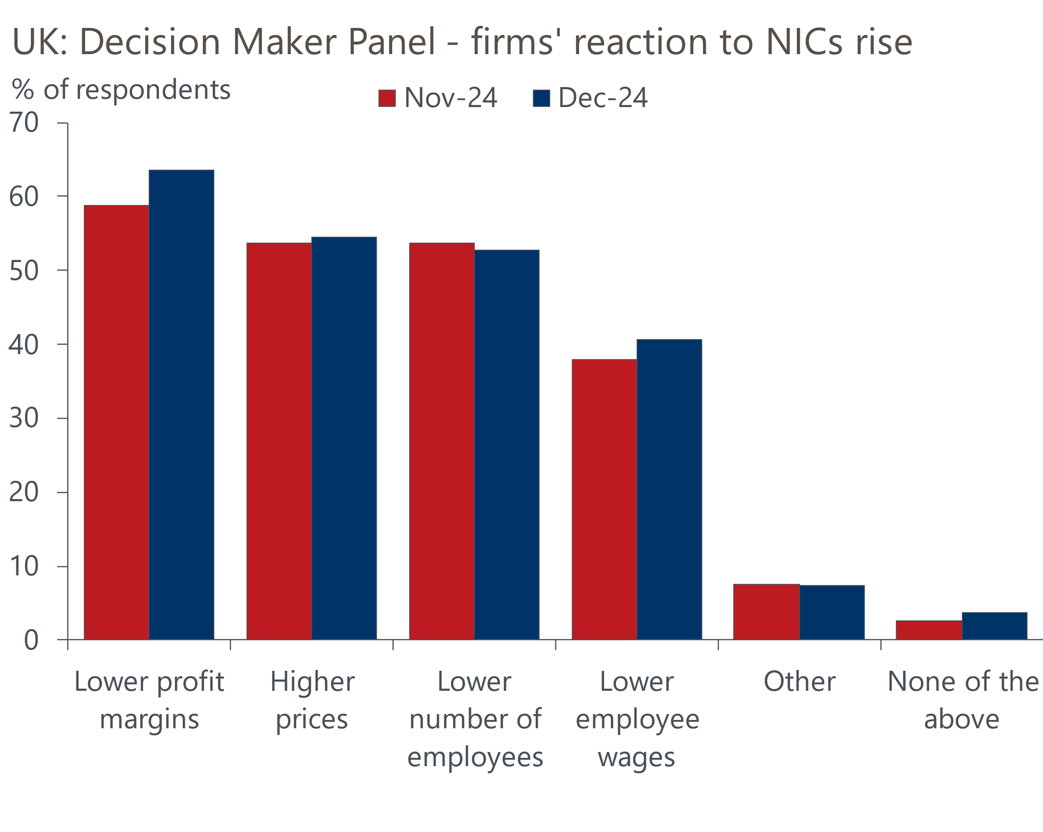
Source: Bank of England Decision Maker Panel
At an aggregate level we expect the NICs and NLW increases to mitigate the impact of cooling pay growth on unit wage costs and further squeeze corporate profits, which were already at a 17-year low as a share of GDP. But the impact is likely to be uneven across sectors.
A large part of the increase in tax revenue from higher NICs will come from lowering the threshold at which firms start paying the tax. So the proportionate impact of the tax increase will be greatest for lower-paying jobs. With the costs of these roles also affected by the NLW increase, sectors employing high numbers of lower paid workers will disproportionately feel the squeeze from these policy changes. Given these sectors are typically also the most labour-intensive, this raises the risk of significant job losses, potentially pushing up unemployment in 2025.
All this means developments in the labour market over the next twelve months will be key to the UK's economic performance. In our next report, we will examine the issue of data problems in greater detail and look at the steps we're taking to fill the information void.

